Children seem to be infected less frequently than adults. Most children who get Coronavirus have had close contact with an infected person. So far, less than 5 in every 100 infections have been in children. There have been reports of COVID-19 causing a severe illness in children, with a fever lasting more than five days, a rash, swollen glands in the neck, red fingers or toes, and dry, cracked lips. This is very rare. But if you have concerns about your child, it’s very important you call 111 for immediate advice. As you can see, many of the less serious symptoms of COVID-19 are similar to those of a bad cold or flu. So it can be hard to diagnose COVID-19 without testing. If your doctor thinks that you might have COVID-19, you might need some tests, such as collecting a sample from your nose or mouth, blood tests, a chest x-ray, or another type of scan of your chest called a CT (computed tomography) scan. Some people who are seriously ill with COVID-19 can develop problems with their kidneys, liver, blood, heart, or brain. If this happens, you might need more tests and extra care.

PREGNANT & BREASTFEEDING WOMEN
We don't know for certain whether the virus can pass from a mother who is infected to her baby in the womb, or to a baby through breastfeeding. The symptoms of COVID-19 during pregnancy are the same as in people who are not pregnant. If you are pregnant and you develop symptoms, you should contact your doctor straight away. You might need regular ultrasound scans during your pregnancy if you have had COVID-19. And you and your baby might need extra monitoring during labour and after the birth. In the UK, it is recommended that pregnant women should follow strict social distancing measures.

PREVENTION
You can take measures to reduce your risk of being infected with COVID-19. These include:
• Washing your hands often with soap and water for at least 30 seconds
• Use an alcohol-based hand sanitiser
• Avoiding touching your eyes, nose, and mouth with unwashed hands
• Cleaning and disinfecting frequently touched surfaces every day including phones, light switches, handles, etc.
• Avoid close contact with people who are sick.
• Keeping at least 2 Metres distance between people

HOW DO PEOPLE CATCH COVID-19?

COVID-19 is able to spread from person to person. The virus spreads when people cough or sneeze, and when people touch objects and surfaces that have the virus on them. The virus can survive for up to 24 hours on cardboard and for up to three days on stainless steel and plastic. Infected people can spread this virus even if they don't have any symptoms yet. You are more likely to get the infection if:
• You live in, or have travelled to, an area where COVID-19 has been reported
• You have been in close contact with someone who has COVID-19
• You are having treatment for cancer
• You are older
• You are male
• You are obese (very overweight)
• You have chronic kidney disease.
Research in some countries, including the UK and US, has found that people of black and Asian origin are more likely than white people to become infected and to have severe symptoms.

WHAT ARE THE SYMPTOMS?
• Fever
• Coughing
• Shortness of breath
• Loss of sense of smell, and
• Reduced sense of taste. Less common symptoms can include:
• Aches and pains
• Feeling tired, Nauseous or Vomiting
• Diarrhoea
• Abdominal (tummy) pain
• Loss of appetite
• Coughing up a lot of phlegm or Blood
• Sore throat
• Headache, Confusion & Dizziness
• Blocked or runny nose
• Conjunctivitis (red or watery eyes)
• Skin rashes
• Chilblains

Dr Kulshrestha Summerfield Family Practice
134 Heath Street, Winson Green, Birmingham, B18 7AL
Tel: 0121 411 0362
www.summerfieldfamilypractice.com

CORONAVIRUS
PATIENT INFORMATION LEAFLET

This leaflet is about the COVID-19 (coronavirus) outbreak that began in China in December 2019. The World Health Organisation (WHO) has declared the outbreak a pandemic. This means that it has spread across the world. This virus can cause a severe lung infection, and it can cause death. You can use our information to talk with your doctor if you are concerned about COVID-19.

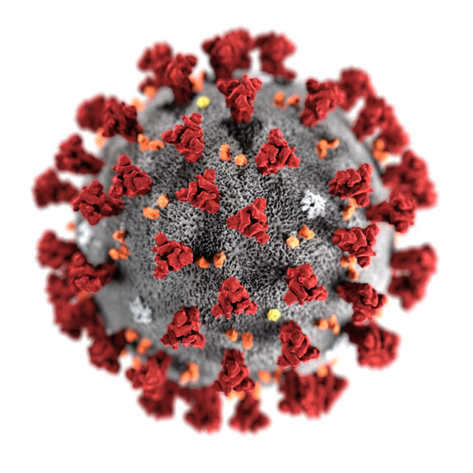
What is COVID-19? COVID-19 is a disease caused by a type of virus called a coronavirus. This is a common type of virus that affects both animals and humans. Coronaviruses often cause symptoms like those of the common cold. But sometimes they can cause more serious infections. The coronavirus that causes COVID-19 is a new type of coronavirus. Most of the first people affected had links to a seafood and live animal market in Wuhan City, Hubei Province, China. This suggests that this new coronavirus might be a combination of human and animal coronaviruses. The virus has now spread around the world. The US, India, Brazil, Russia, Argentina, France, Spain, Colombia, and Peru are the countries with the most confirmed cases.
PLEASE TAKE
A COPY

You should follow any national or regional policies on social distancing. Depending on where you live, this may include:
• Cancelling or limiting the size of public gatherings
• Not attending schools and universities
• Not visiting cafes, bars, restaurants, and other businesses
• Working from home if possible
• Only leaving the house for essential journeys: for example, to buy food or medicine
• Not letting your pet interact with people and animals outside your household.

At this time, there is no evidence that pets and other animals can spread COVID-19 but caution is advised. Cats can become infected after contact with people who have COVID-19. Scientists are carrying out research in this area.

IF YOU BECOME ILL, YOU SHOULD:
• Stay home and avoid contact with other people
• Seek medical care right away, but call 111 and tell them about your symptoms
• Not travel while you are unwell
• Cover your mouth and nose with a tissue or your sleeve (not your hands) when coughing or sneezing, then put the tissue into the bin
• Wash your hands often with soap and water for at least 20 seconds, especially after coughing, sneezing, blowing your nose, or being in a public place.
• Use an alcohol-based hand sanitiser
• The World Health Organization advises that you should wear a mask if you are a healthcare worker or if you are caring for someone with COVID-19 at home, or when social distancing is difficult.

MASKS & FOOD PRODUCTS
If you choose to wear a mask, you should wash your hands with soap and water, or use an alcohol-based hand sanitiser, before putting on the mask. You will still need to wash your hands often and thoroughly while wearing the mask. The chance of the infection spreading from food products or packaging shipped over a period of days or weeks is very small. The UK government advises it is very unlikely that you can catch COVID-19 from food. But you should follow good hygiene and preparation practices when handling and eating raw fruit, leafy salads and vegetables. This means washing fresh produce to help to remove any contamination on the surface and peeling the outer layers or skins of certain fruits and vegetables.

VITAMIN D
Vitamin D is important in keeping your immune system strong and preventing infections. We can't yet say for certain if it helps prevent COVID-19. But there is some evidence that it helps prevent chest infections. Many people don't get enough vitamin D, especially in the winter months. This is because we get most of our vitamin D from sunlight on our skin.
So some sun exposure on most days is important. But remember: too much sun can cause skin cancer, so it's important to avoid burning. In some countries, such as the UK, it's now recommended that people take a daily vitamin D supplement. This is especially important in the winter months, and if you spend a long time indoors because of lockdown rules.

WHAT TREATMENTS WORK?
At this time there is no cure for COVID-19. A vaccine is being developed, but it will be some time before it is available. Different medicines are being tested to see whether they can help patients with COVID-19. The research is in the early stages, so these medicines are normally only given as part of a clinical trial. A drug called remdesivir may be used in patients who have severe COVID-19. Remdesivir is a type of drug called an antiviral, which means that it is used to fight viruses. In some countries, including the UK, powerful anti-inflammatory medications called corticosteroids are being given to some people with severe breathing problems. Early research suggests that this treatment can help some people to breathe more easily and prevent death. Other drugs are being studied to see if they might be useful. Another treatment is being developed from the blood of people who have recovered from COVID-19. Their blood contains proteins called antibodies, which can stick to the virus that causes COVID-19 and help to fight the infection. This treatment is called convalescent plasma.

HOSPITAL TREATMENT
The treatment for someone with COVID-19 is the same as for pneumonia or any other serious viral chest infection. If you are treated in hospital, the treatment will consist of:
• Making sure you get plenty of fluids, possibly through an IV (intravenous) drip
• Medication to lower fever and reduce pain, if needed
• Oxygen, if you need it
• Close monitoring

You might also be given antibiotics to begin with, in case you have a bacterial infection. But if testing shows that you have a viral infection, the antibiotics will be stopped, as antibiotics don’t work against viruses.
People with severe symptoms might be treated in an intensive care unit (ICU). If you need to be treated in intensive care, your treatment might also include:
• A tube passed through your mouth to your windpipe, called an endotracheal tube
• A ventilator to support your breathing.
Some people being treated in hospital might also need treatment for sepsis.
.
HOME TREATMENT
People with mild symptoms can probably be looked after at home until they can be tested. In the UK, people who have symptoms are advised not to go to hospital right away, but to stay at home and contact their health authorities, and to follow their advice. This will help stop the spread of the virus. The guidance for looking after them at home is as follows:
• They should be looked after in a well ventilated room by themselves, and should stay in that room as much as possible, so that they don’t spread the infection
• The number of people who look after the ill person should be limited to as few as possible.
• Ideally, anyone looking after the ill person should be in good health.
• If you wear a medical mask while looking after someone with symptoms, change it for a new one if it comes into contact with their bodily fluids
• Wash your hands thoroughly after touching the ill person. You might want to wear disposable gloves, such as latex gloves.
• Dispose carefully of any tissues the person uses.
• Don’t share anything like towels or bedclothes with the ill person
• Carefully wash any plates, drinking glasses and cutlery after they use it.
• Regularly wipe and disinfect any surfaces the person touches regularly, such as bedside tables.
• Clean toilet and bathroom surfaces regularly
• The ill person should limit contact with pets and other animals.
• Keep taking any prescribed medications, unless your doctor recommends that you stop
IF IN DOUBT CALL 111

